2100
OUTER BANKS

Pique Sport Shirt

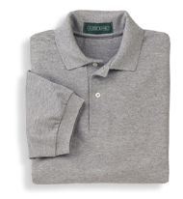

Descriptions
*100% Cotton, 6.5 ounces
*Welt collar and cuffs
*2 Button pearl buttons
*Double needle bottom hem
*Embroidery only

Finished Garment Measurements

Size | S | M | L | XL | 2XL | 3XL
Width | 19 ½ | 21 ½ | 23 ½ | 25 | 26 ½ | 28 ½
Length | 28 | 30 | 31 | 32 | 33 | 34
Sleeve Length | 10 | 10 ½ | 11 | 11 ½ | 12 | 12 ½
Shoulder Width | 17 ½ | 19 | 20 ½ | 22 | 23 ½ | 25

